Machine Learning Algorithms

Name of student

Name of professor

University

Course

Date:

**Introduction:**

In a world of fast moving data and data consumerisms, there is a rising need to fil the gap between the avaible information technology sources and the gap that this needs to fill. Data wrangleing, data clean up and analytics is not just enough for the futire of intergrated data systems. In this view, there is need to evelaute historcaally, present and current data systems and architectures currently in place. This creates a veracity of form. For instance, having data coming in from social media feeds, web portals, mobile apps and emails platforms.

This has henece created a need for an intregtaed, single source of truth and real time database system called Business Intelligence system. BI studies past data, stores it, learns from it, and based on the prescribed algorthms and programs, is able presnt before the user, a variety of analytics and possinble predictive analytics situations as on the databse system. The BI usually aims to achieve the below cases:

1. Data storage
2. Real time analytics
3. Predicitve analytics

Data storage: A BI tool has the propensitity to store huge amounts of data.This can be done either on a relational databse system or a non-relationla datanase system. Most organisations however use the old relational models. Some of the databse types that support this kind of implementation include MYSQL, Postgress, Oracle or DB2. There are a number of reasons as to why relational datasbse systems are widley adopted. They include:

* Easire to use and querry
* Simple data organization

Un-relational databse systems on the other hand do not specifically illustrate the kind of data that they contain or that which should go into them. They can take any set of data parameters such as images, audio, video and text into the database, something that is not easier to implement in relational database systems. This kind of technology is widely implemented in Big data arena. One of the most occurring challenges of Big data is the complexity in analaysing the data theirin, howewever, other databse applications like Hadoop, Apache Spark are still able to implement this kind of analysis.

Real-time analytics: Another opportunity that is presented by BI applications is the ablity to give realtime analytics to the Business whenever there is need. This happends wheneeer the BI application is connected to the database server and then the server supplies the application program with the necessary tables that are needed for analytics. What happens is behind the secnes, there are a number of programs that have already been written to help achieve a prtular output like graphs, summaries, counts, measures of central tendencices and trends of time. At a higher level, the BI tool will always predict the futire the data that is currently being analysyed. This is for instance possible to achieve with a programming language like Python and a tool set called Jupyter Notebook. Within the Jupyter notebook, a developer would then proceed to write the necessary codes and programs that together with the desired algorithm will achieve the desired outputs. Some of the algorithms in this case include KNN, Bayes classifiers, Random forest and linear regressions.

**Problem statement:**

This document illustrate the need for an effective BI solution that will provide the necessary and needed requirements to Business in order to achieve the desired output. The retail company is currently faced with a problem of identifying and utilizing adta that is generate from across its channesls, some of these channels include functions such as:

* Sales
* Supply chaina and procuements
* Human resources
* Customer service
* Inventory
* Information technology
* Finance
* Logistsics and movements

**The business process:**

The business needs visibility across all functions in order to understand what is going on across the company. Though traditionally all the business functions have operated as single entities, by having a BI application, this will give management to have a 360 degree view as to what is actually happening across the departments and then be able to make some informed decionns. Below is a simple illustration diagram of how this happens.

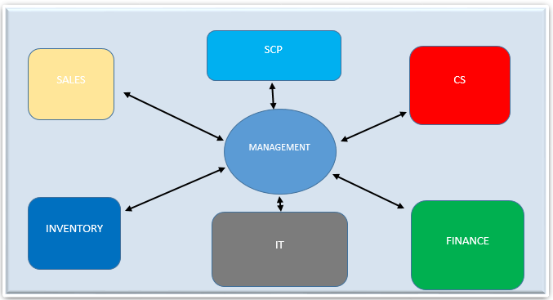

The illsutartion above shows the possible svcenrio of havig the manaegemebt at the core of the business having a clear pictuctre of what is going on in the business and how they can use all these ifmroantion coming in from these sources to make meaningful decions to achieve the company goasl, obejvtives and missions. However, before this is arrived at, the BI implmementation process must make precedence.

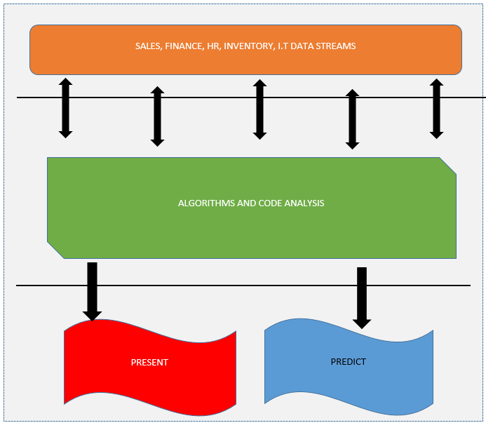

The above shows the stages through the BI module has to go through. The top tire phase shows thefirst phase which includes the incoming data sources from the different functions. These data goes to the different host databases that then direct the data to the algorithm and program controllers. The result is then presented to the user screen for effective decision making.

**Development of the BI solution:**